**----:AWS CHALLENGES:----**

**Launch one EC2 instance using Amazon Linux 2.**

1. 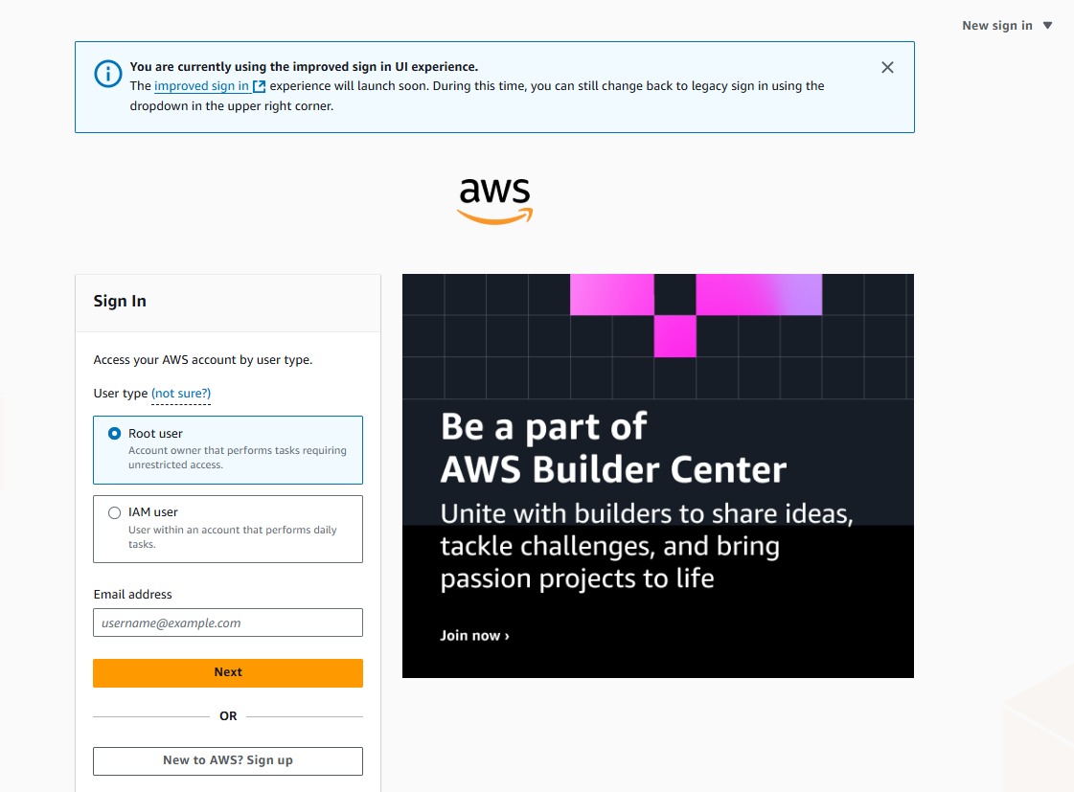Go to aws console and login with your account .
2. Go to dash board and click on launch instance.

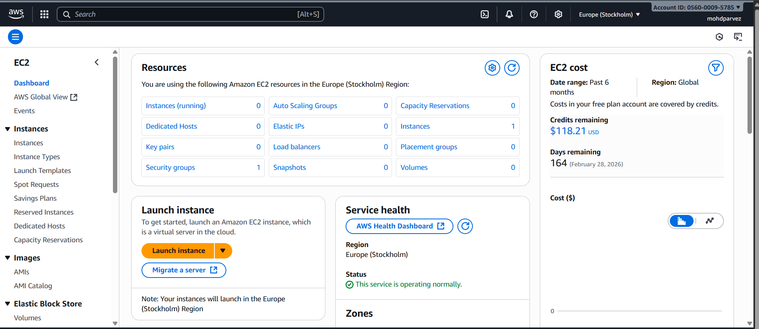



1. 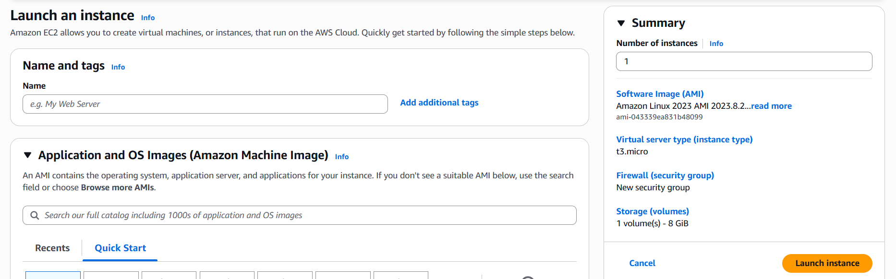then name the instance you want to lauch



1. Select the AMI (amazon machine image you want ).
2. You can see the description of the AMI you are using.

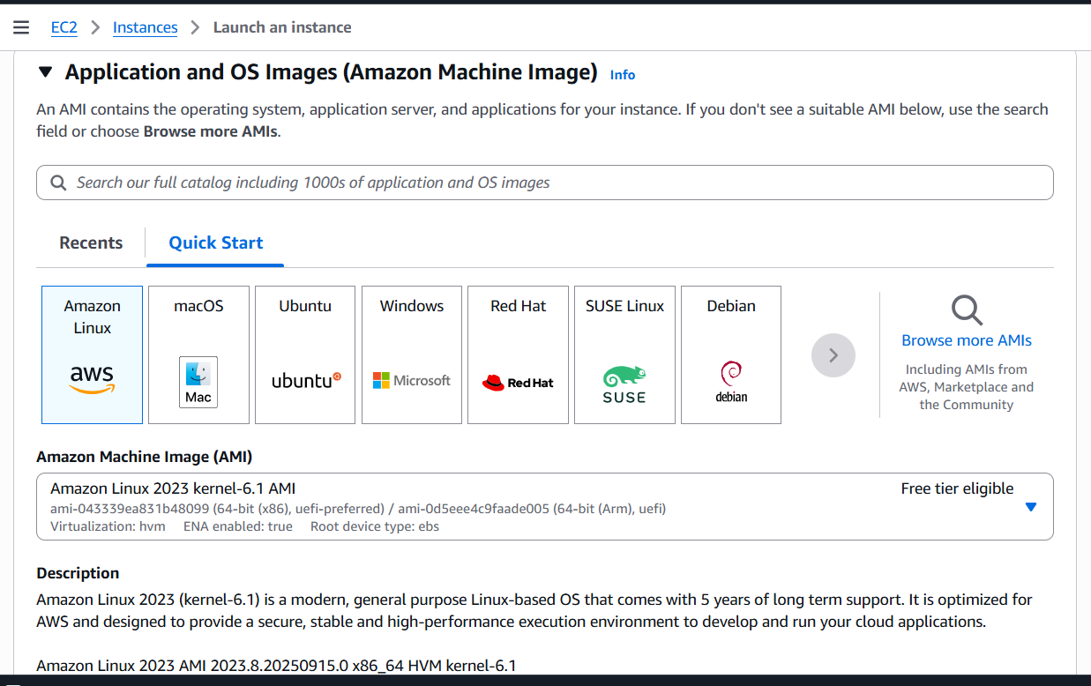



1. Select instance tpe and create key pair ,the key pair will be downloaded on your windows.

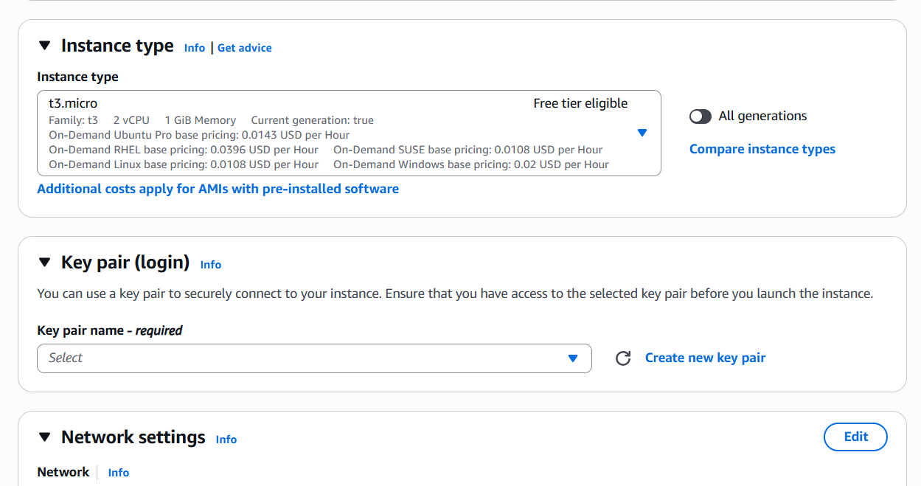



1. Click on create new key pair give the name and click on create key pair.

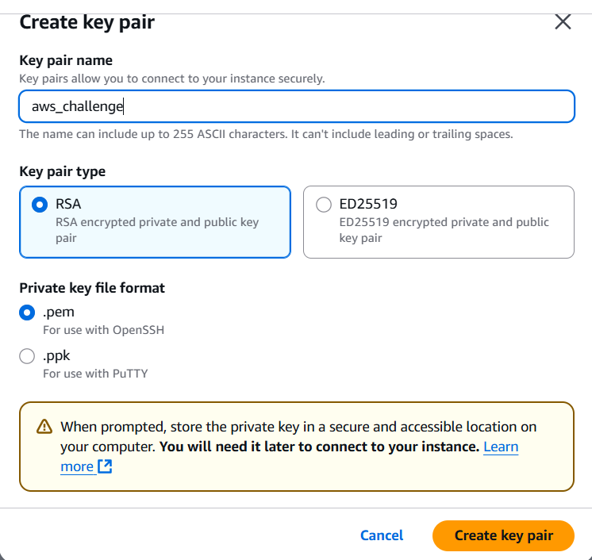



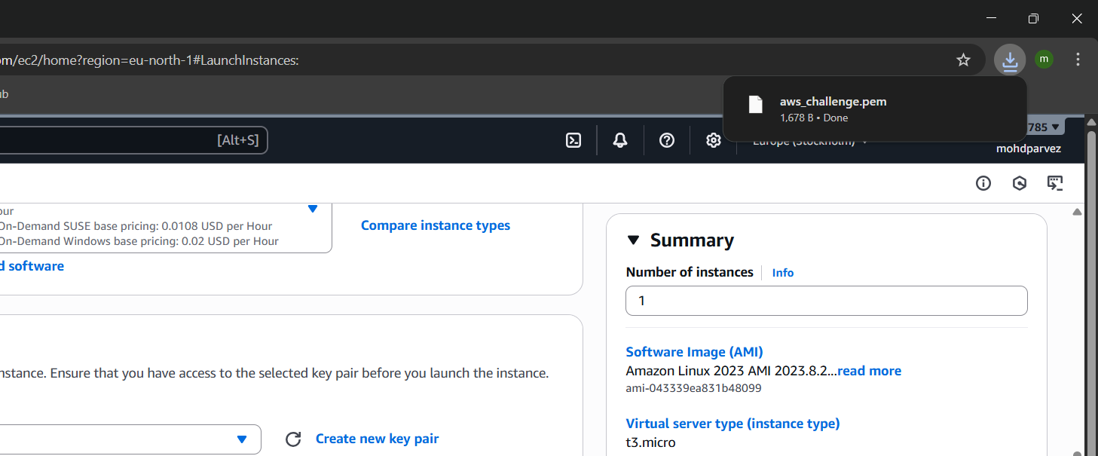



1. 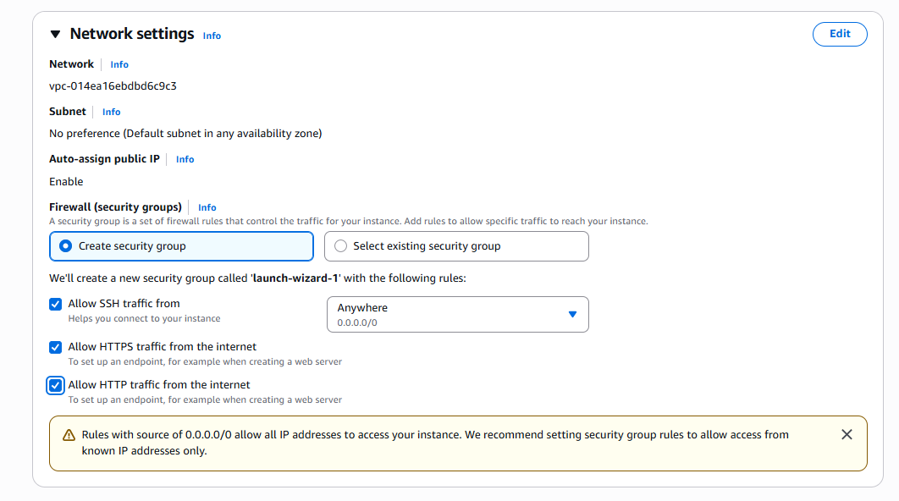 In network setting click on allow all and do not do any changes for fire wall security group.



1. Configure the storage as required .

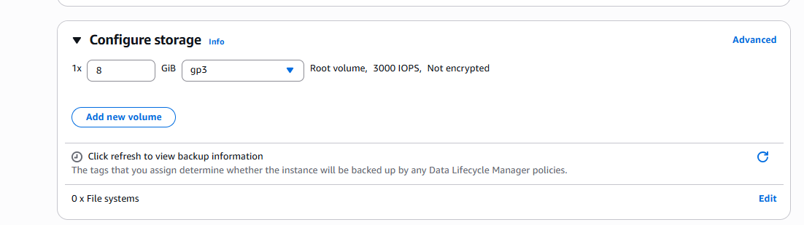



1. After all configurations of the ec2 instance is set click on launch instance to launch the instance.

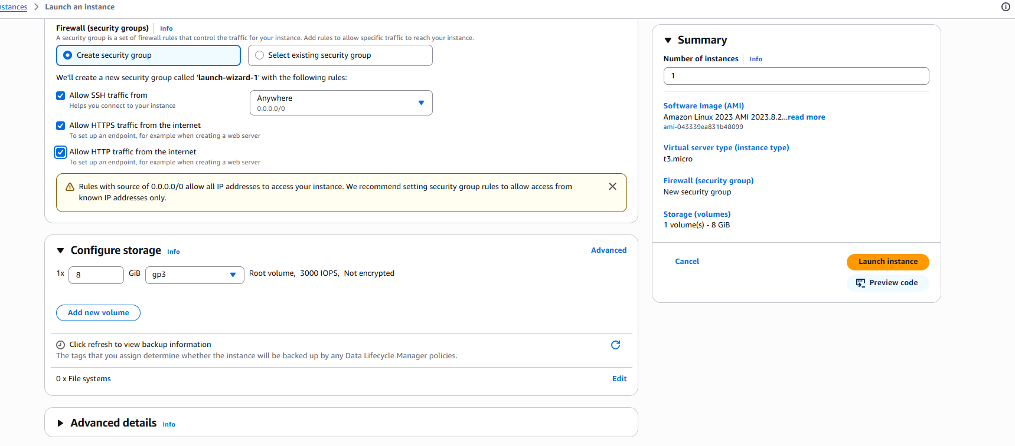



1. It will show the lauching window an then the instance is launched .
2. 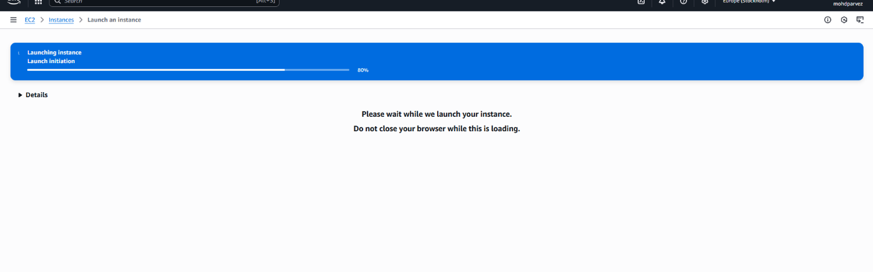It will show the lauching window an then the instance is launched .



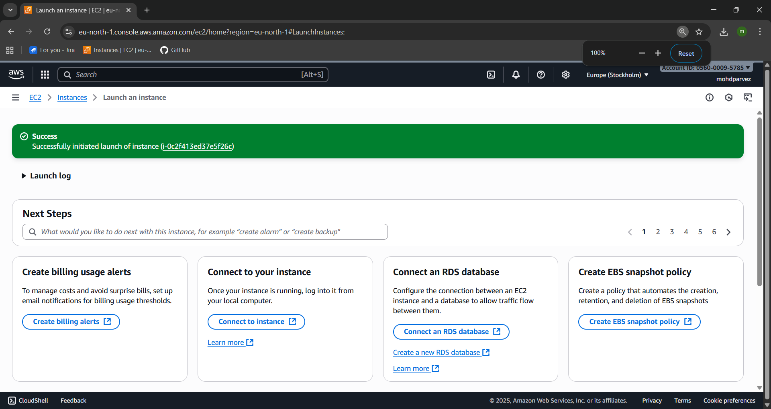

1. You can see that the instance has successfully started.

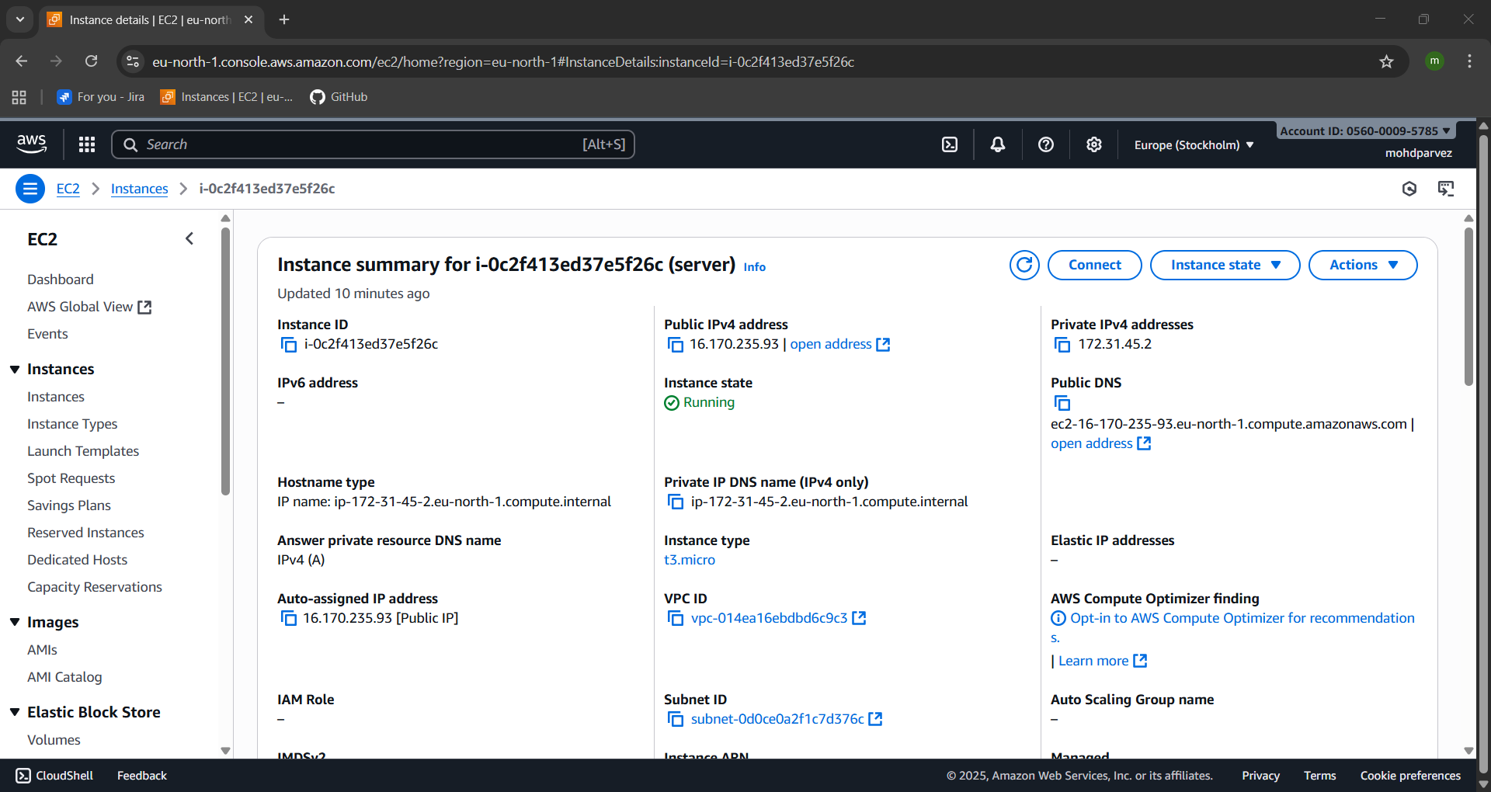



**INSTALL DOCKER:**

1. connect to the aws ec2 instance through pem key.
2. Go to the folder where the pem key is downloaded.
3. Right click and open git bash here.
4. Use “ssh -i <keypair.pem> ec2-user@<ipv4 public> , the ip of the instance.



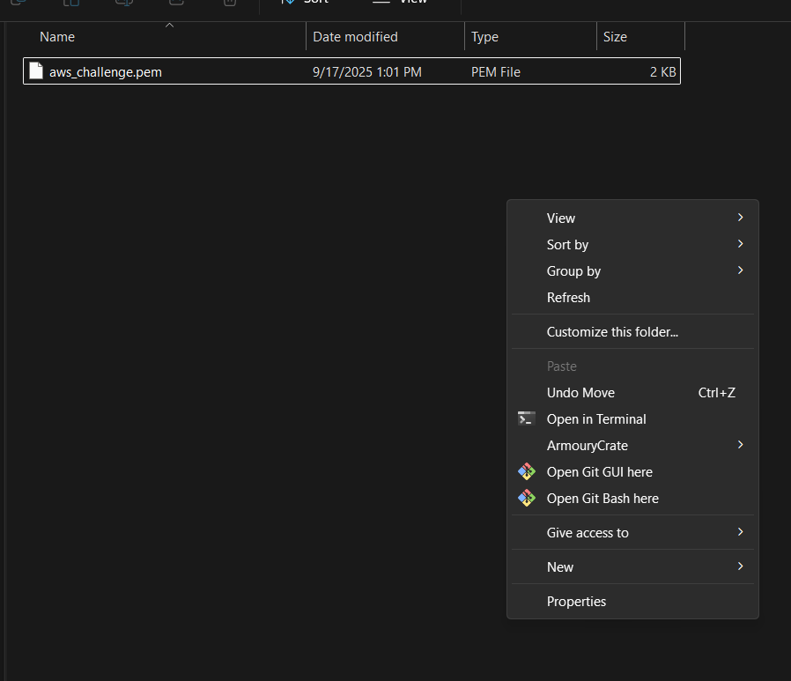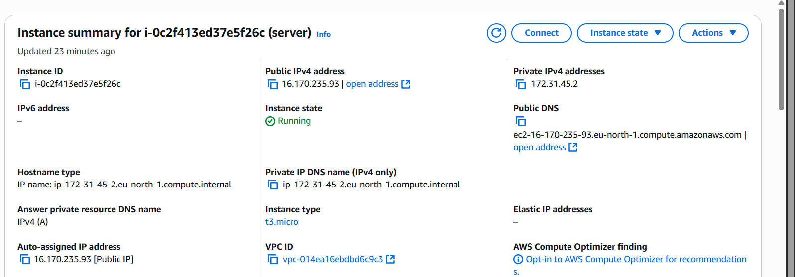



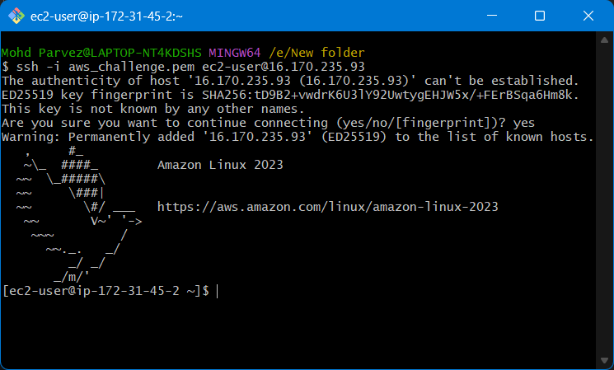

1. Switch to the root user
2. Install docker : yum install docker

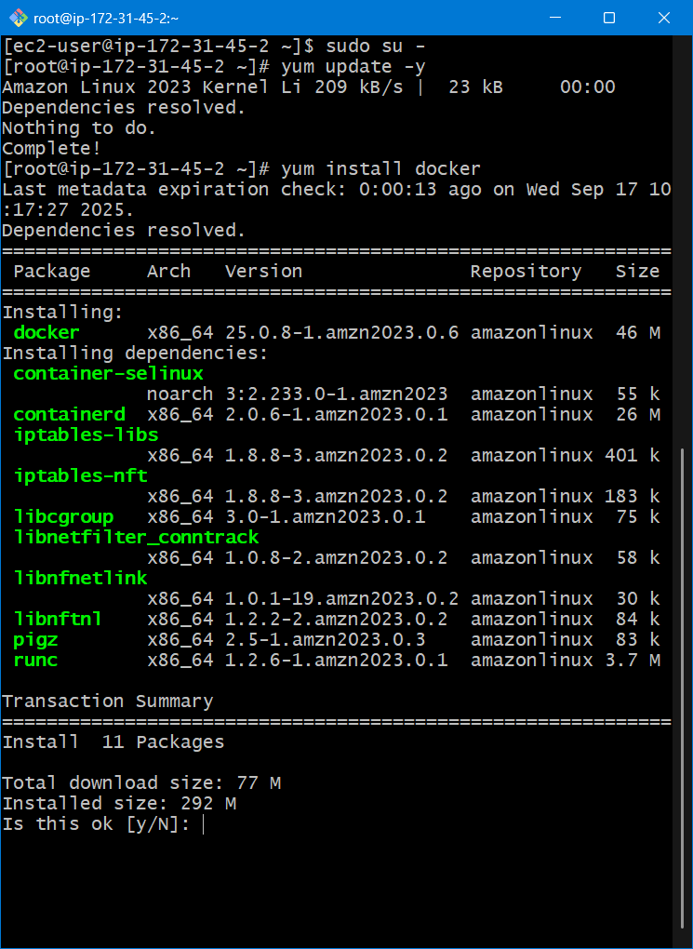



1. Start docker : systemctl start docker
2. Check status : systemctl status docker
3. Check info : docker info

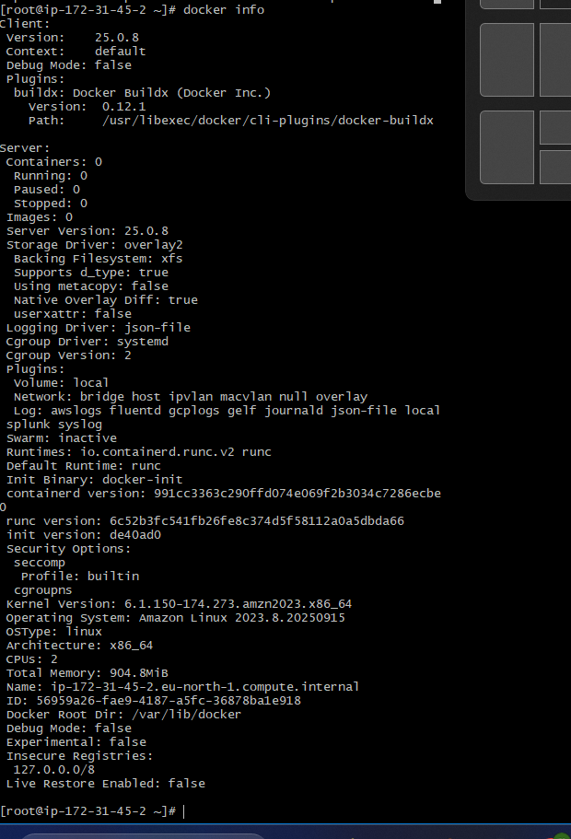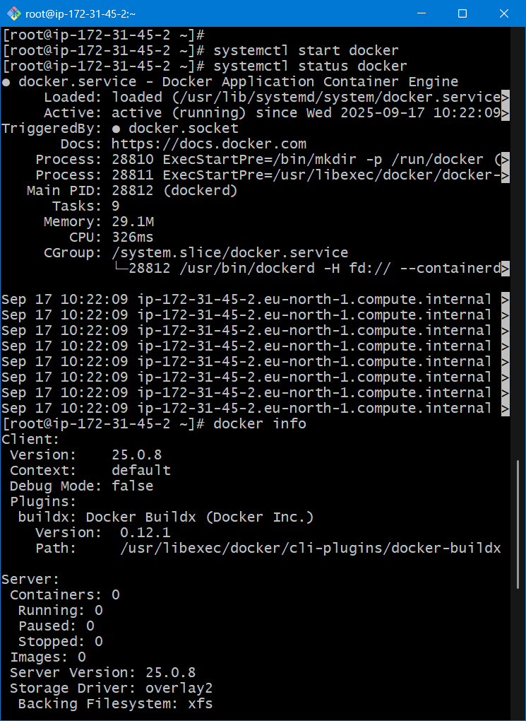



**INSTALL HTTPD:**

1. Yum install httpd
2. Systemctl start httpd
3. Systemctl status httpd

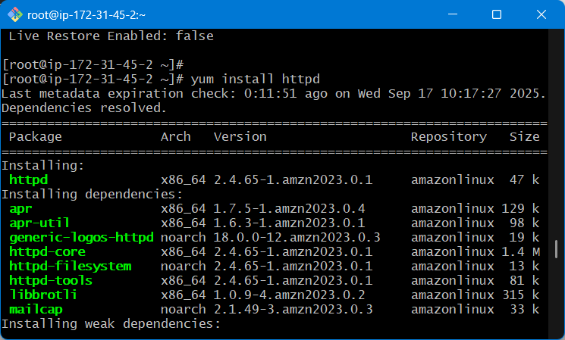



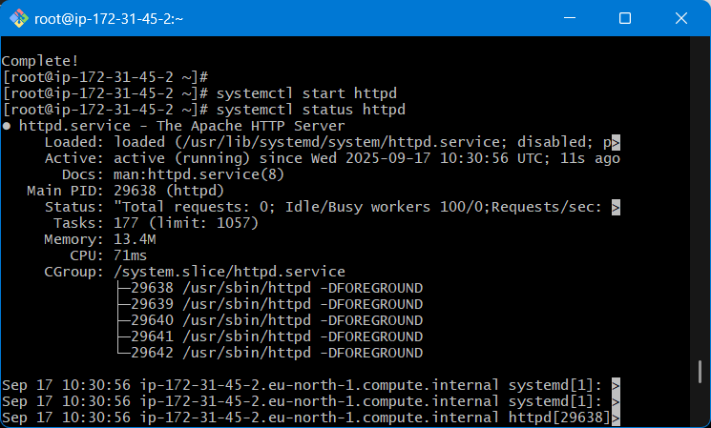



1. To check the httpd(apache) is running got ot browser enter ip address of aw sec instance which you are using and port number
2. <ipadrees>:80(port)
3. 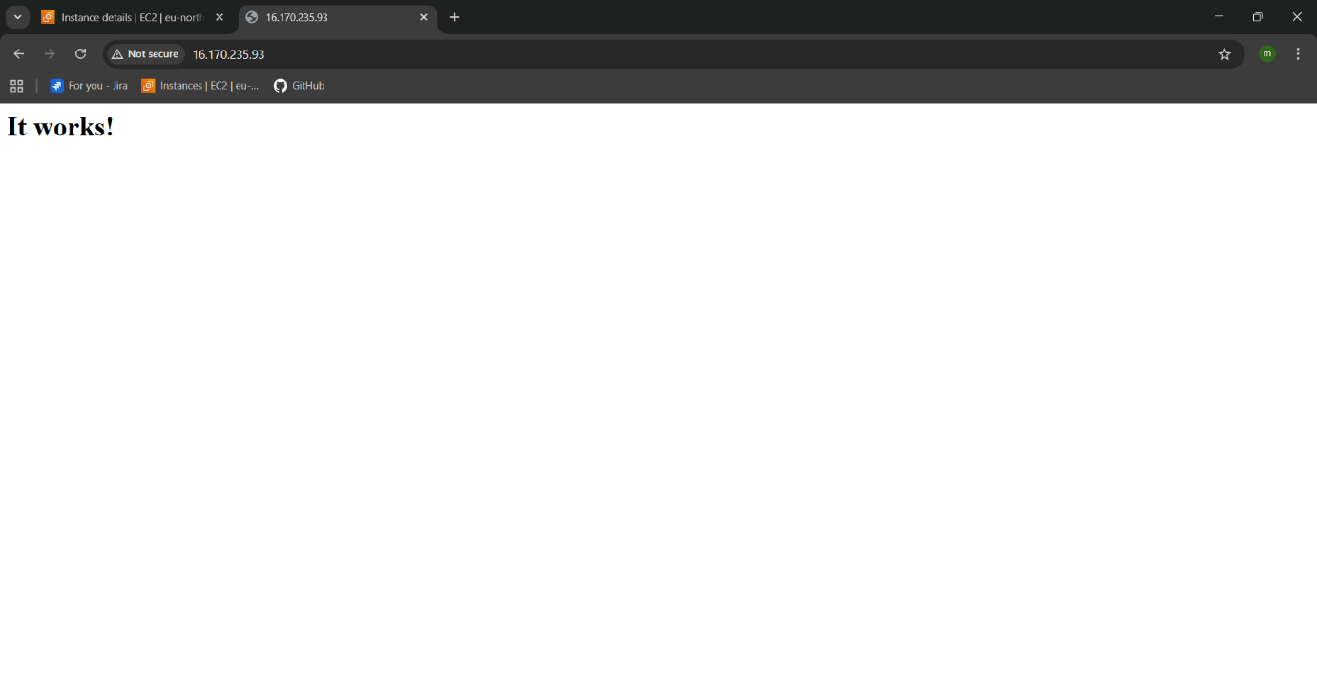you can see the httpd is running .

**INSTALL NGINX:**

1. Yum install nginx
2. The service httpd is running on same port number both the services will not run on the same port in one instance change port in nginx configuration file.
3. Enter : find / -name nginx.conf : to locate the path to the file
4. Then enter : vi /etc/nginx/nginx.conf
5. You get opened into the nginx configuration file

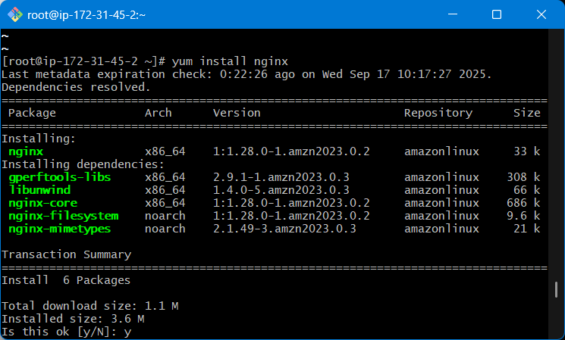

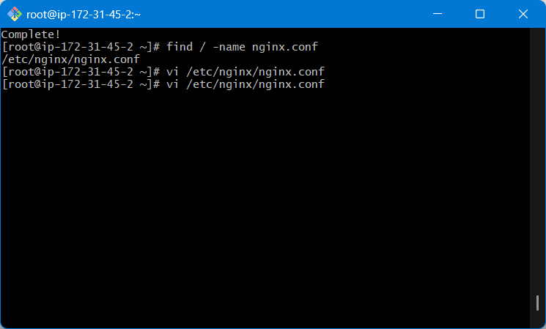

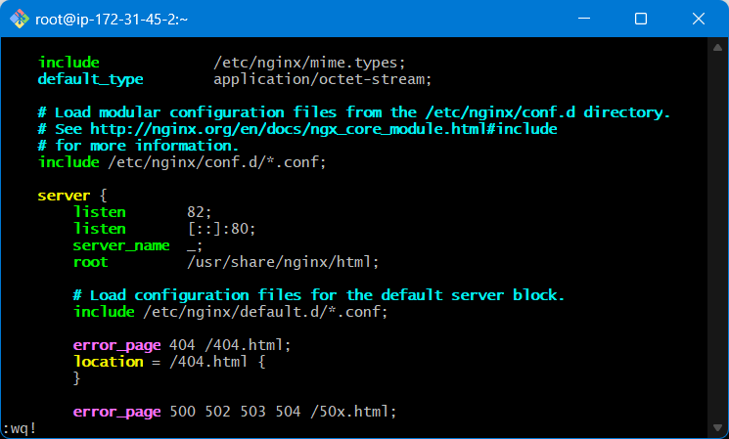

1. Change port yo 80 –81 and save it
2. Start nginx : systemctl start nginx
3. Sytemctl status nginx

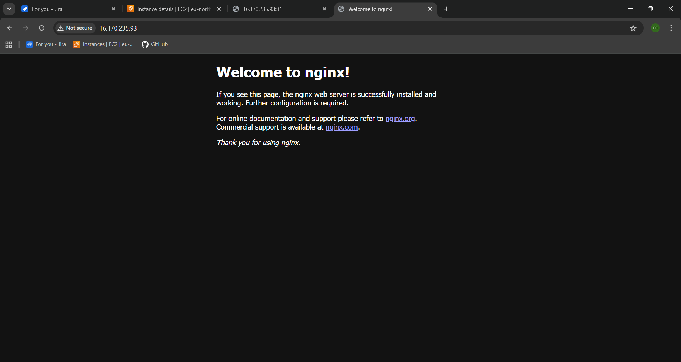

1. You can see the nginx is running in browser

**INSTALL TOMCAT:**

1. TOMCAT dependence on java you need to install java to run tomcat
2. yum install java-11-amazon-corretto -y
3. copy the toncat url from the browser
4. wget “url” :to install tomcat

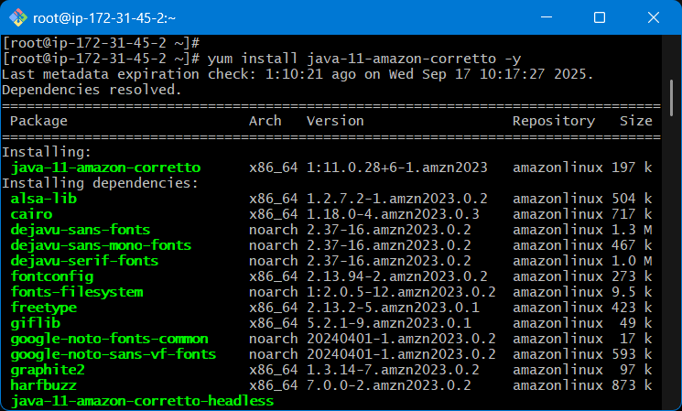

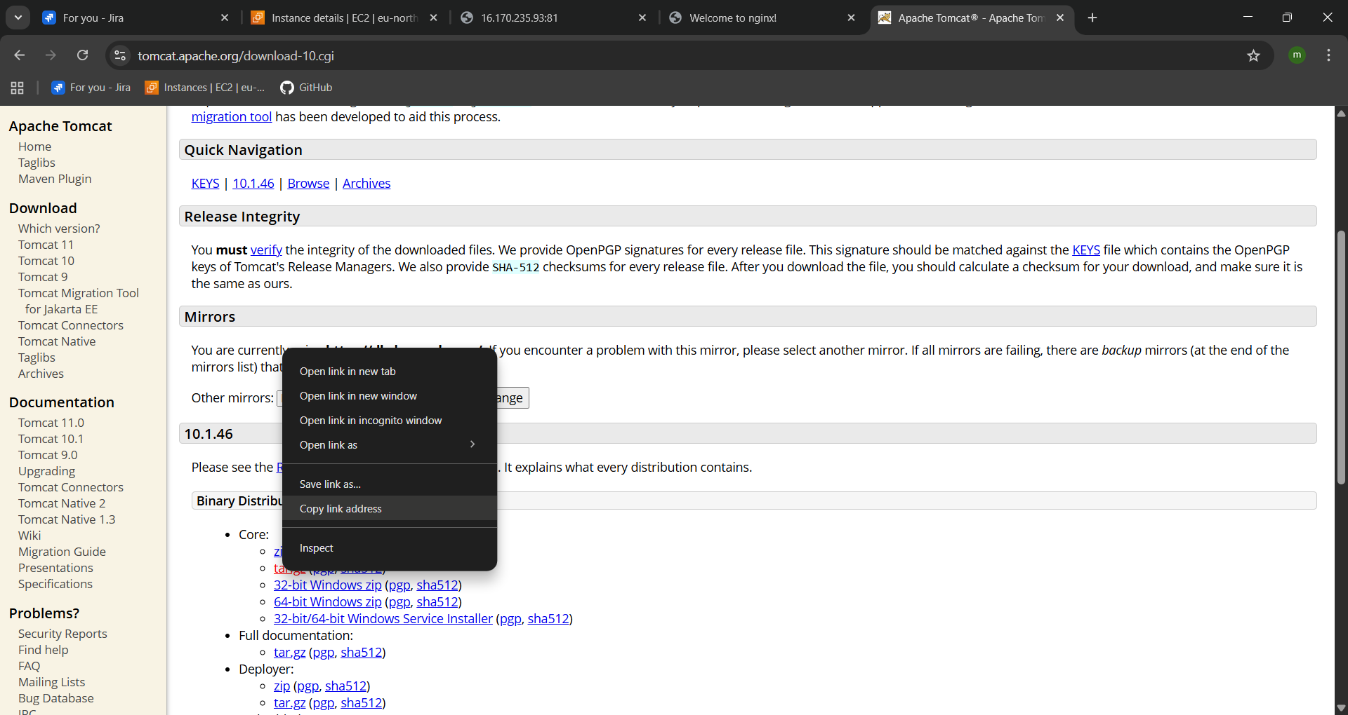



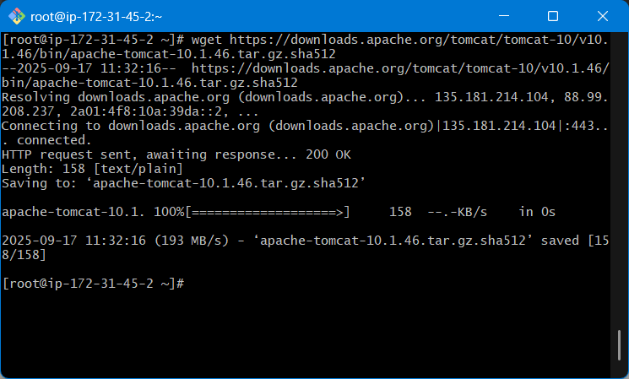

1. extract the downloaded file : tar -xzvf “file name”
2. start the service you need to use “./startup.sh” – that will be in the bin directory if you don’t know the path use : find / -name ./startup.sh
3. you can find the directory to that
4. then you can start the tomcat using : ./startup.sh
5. then you can see the tom cat has started
6. go to browser check the tomcat is running.
7. 8080 is default port for tomcat

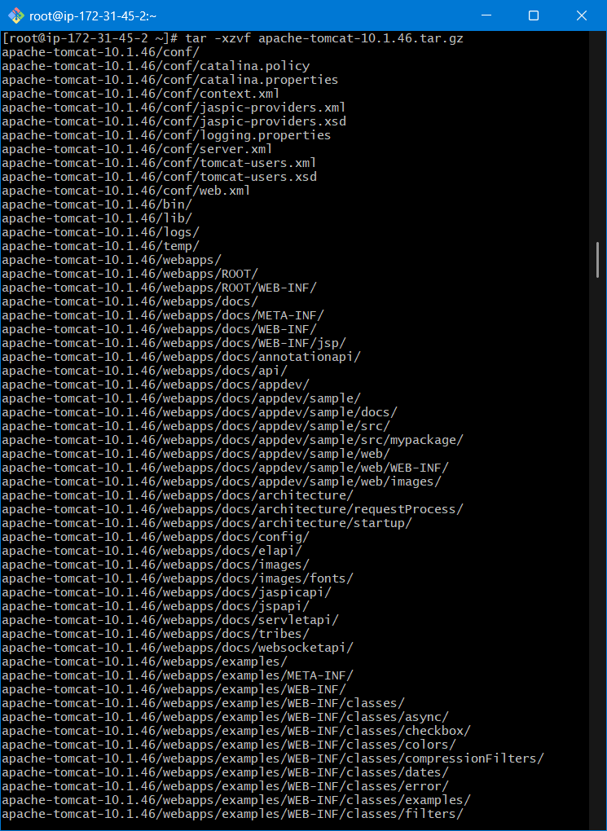

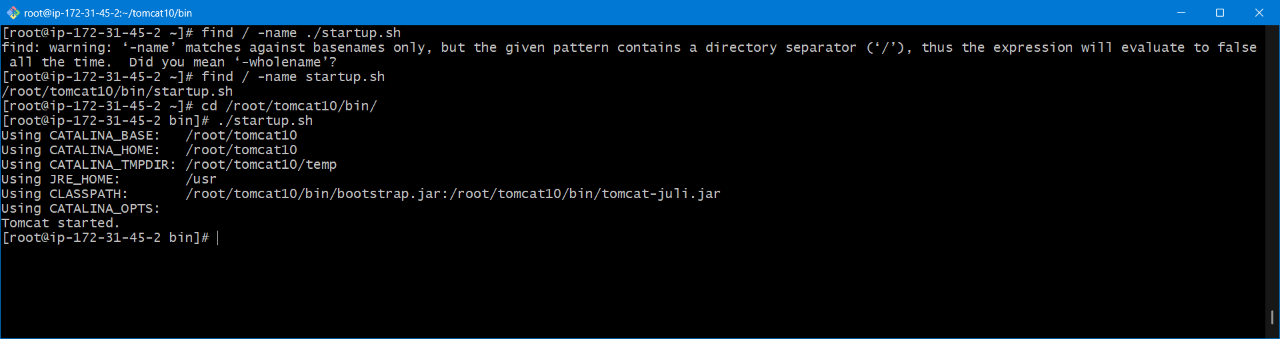

1. to check in bowser enter : <ipadree>:8080

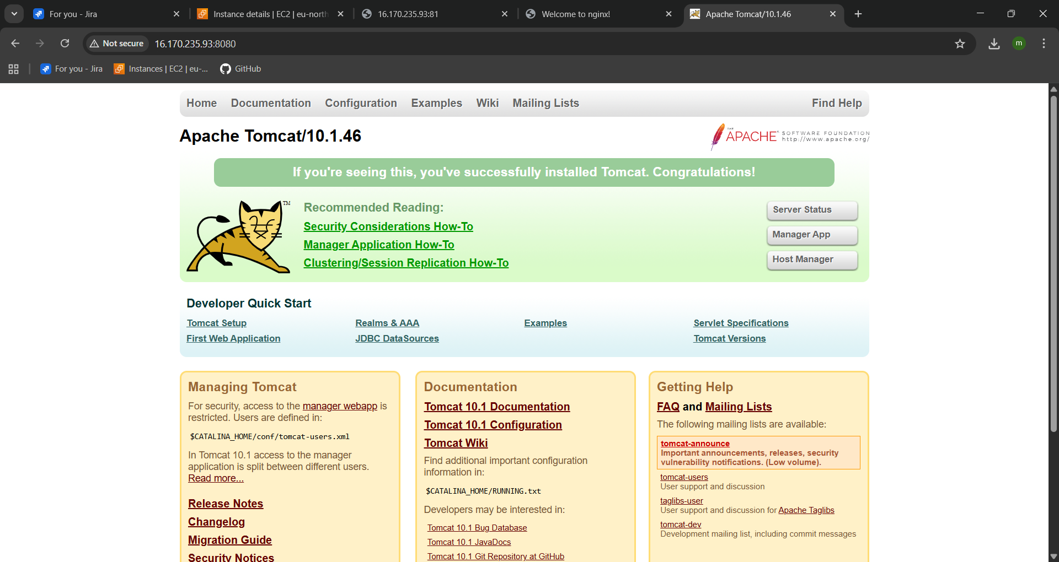

1. You can see that the tomcat is running on browser.
2. You need to install Jenkins the port of the Jenkins and tomcat is 8080
3. Change port of tomcat to 8082 in confihuration file : server.xml
4. After changing port do ./shutdown.sh : to stop tomcat
5. Then again ./startup.sh to start the tocat service
6. Now go and check in the browser using ip address and port number.
7. The tomcat s running on port 8082

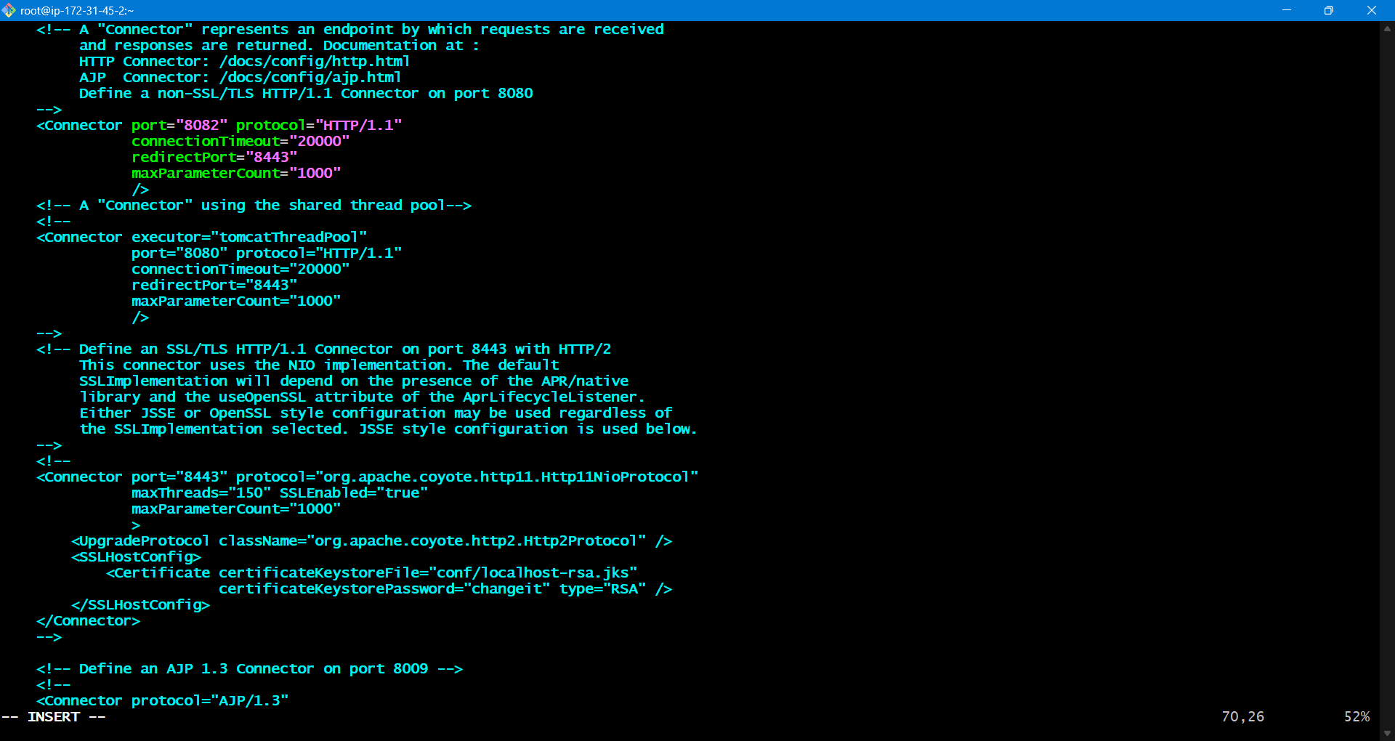

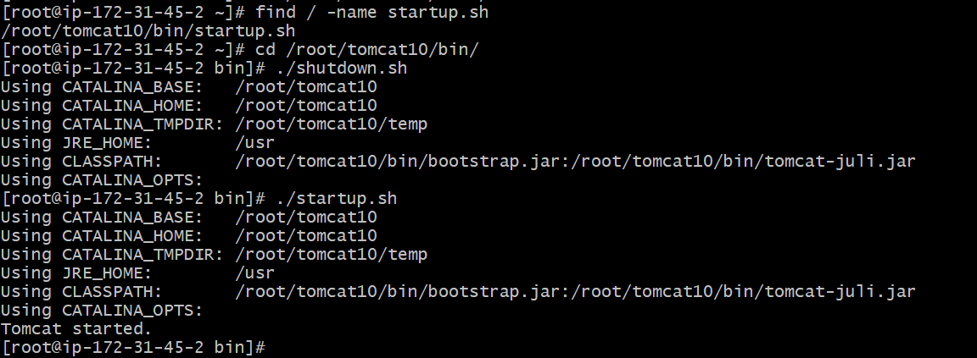

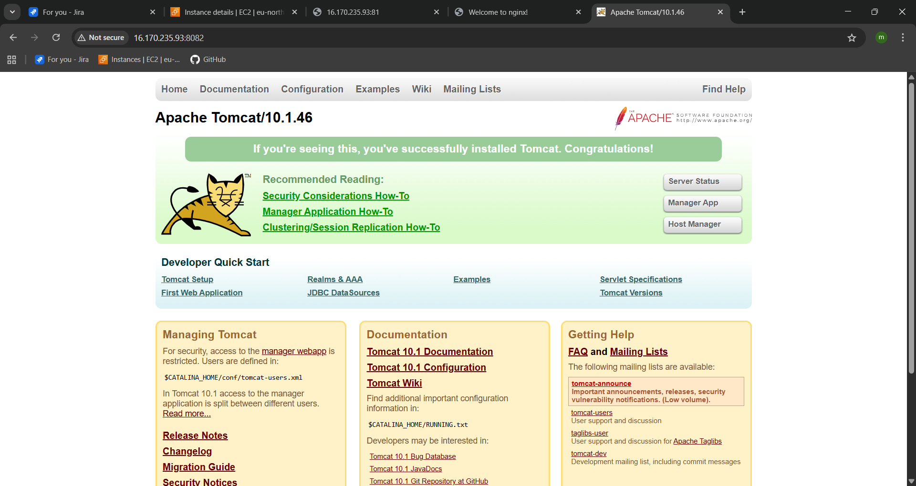

**INSTALL JENKINS:**

1. wget -O /etc/yum.repos.d/jenkins.repo \

https://pkg.jenkins.io/redhat/jenkins.repo

1. rpm --import https://pkg.jenkins.io/redhat/jenkins.io-2023.key
2. yum upgrade
3. # Add required dependencies for the jenkins package
4. yum upgrade
5. Yum install java-21
6. Yum install Jenkins
7. Systemctl start Jenkins
8. Systemctl status Jenkins
9. To change port go to jenckins .service file
10. Find / -name Jenkins.servicce
11. Change port 8080 – 8090
12. Then again restart the service systemctl restart Jenkins
13. Check in the browser to Jenkins is running are not.

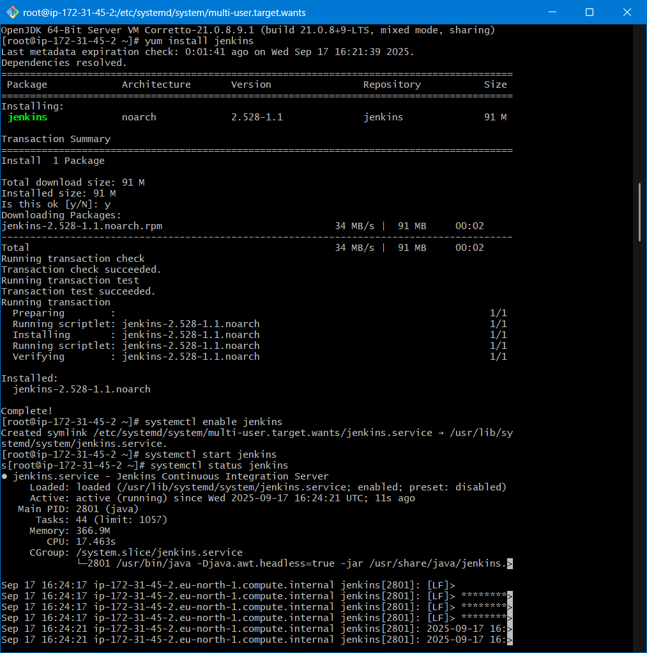

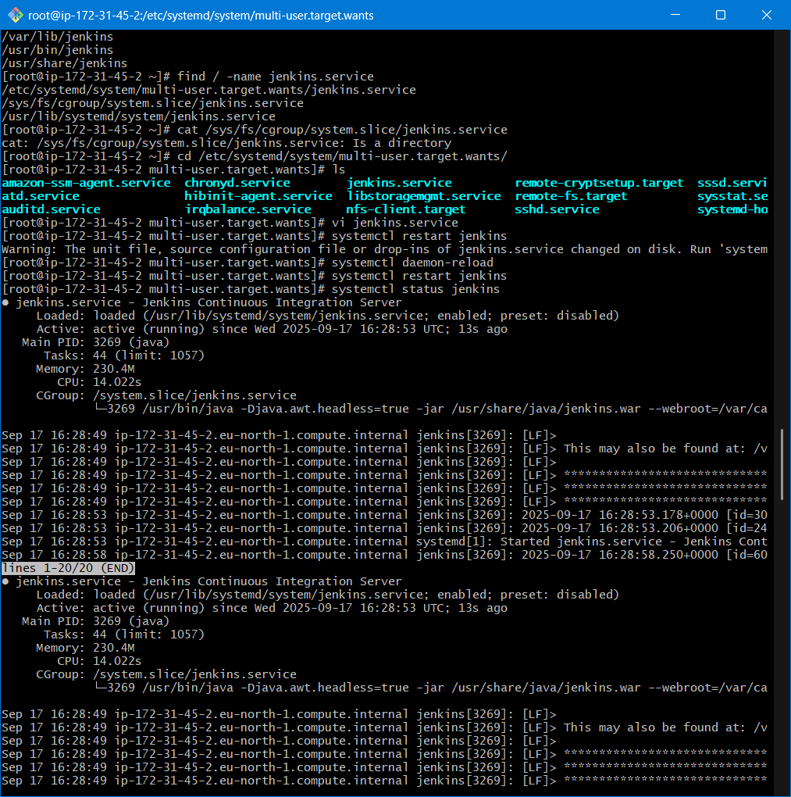

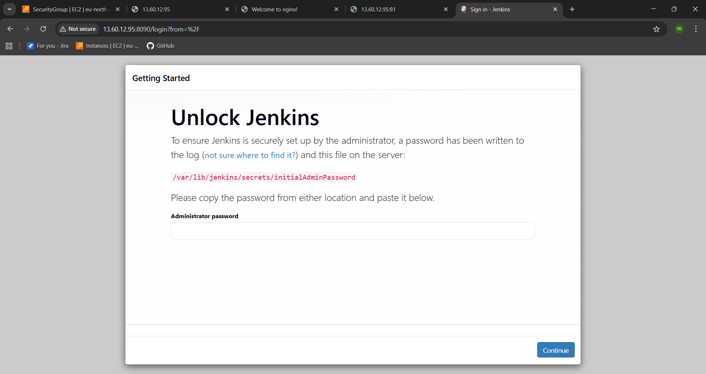

Jenkins is success fully running on port 8090.